

LAB 10

Miss Ayesha Majid

Muhammad Abdullah

53457

## Creating Schema

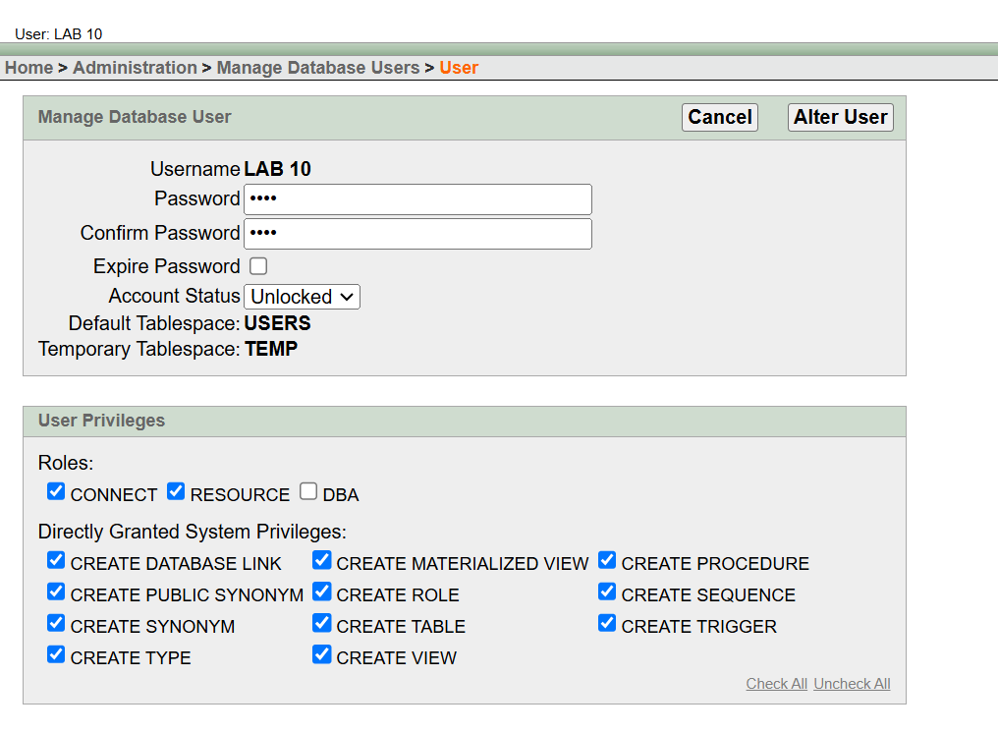

#### **Task 1: Identify FDs**

Given the schema R(EmployeeID,Name,Department,Manager,Salary)

* 1. Write down potential FDs.
     + EmployeeID → Name, Department, Manager, Salary
     + Department → Manager
     + Manager → Department
  2. Insert sample data into the table.

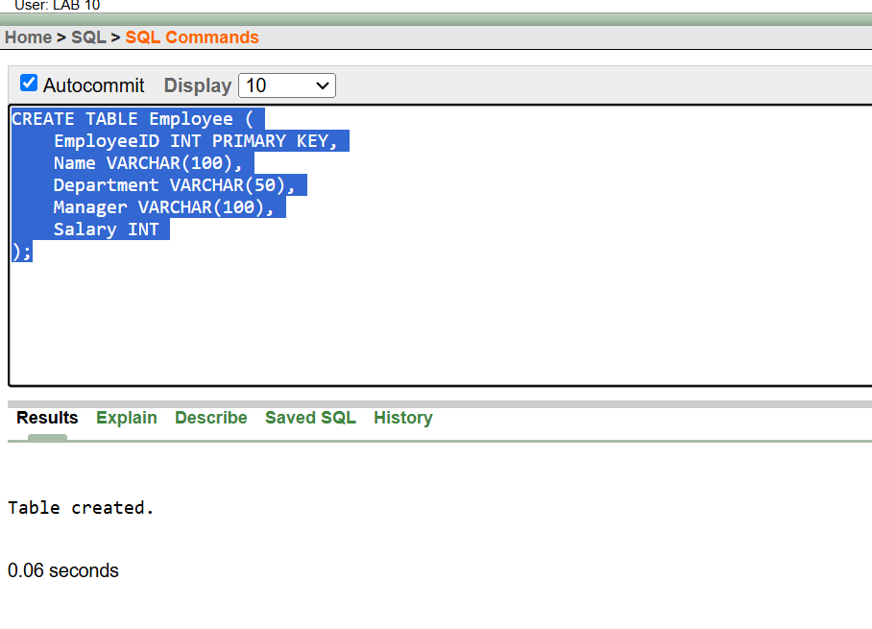

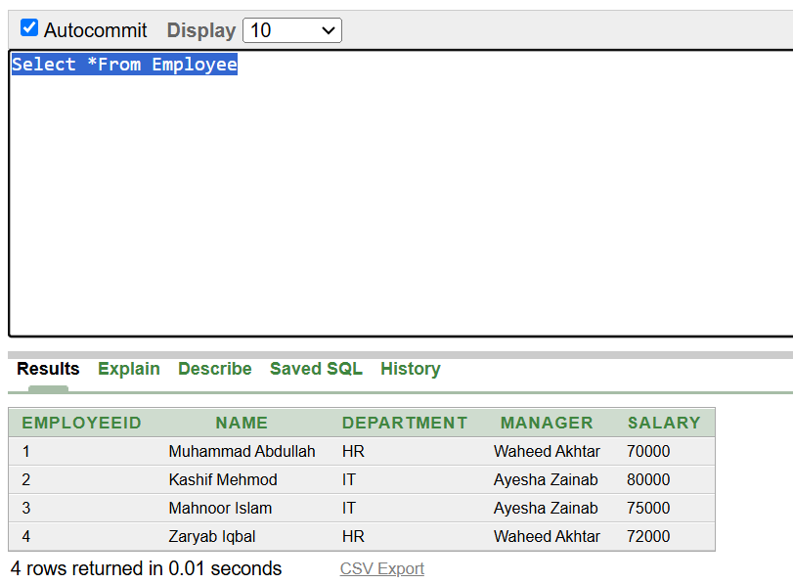

* 1. Verify each FD using SQL queries.
     + EmployeeID → Name, Department, Manager, Salary

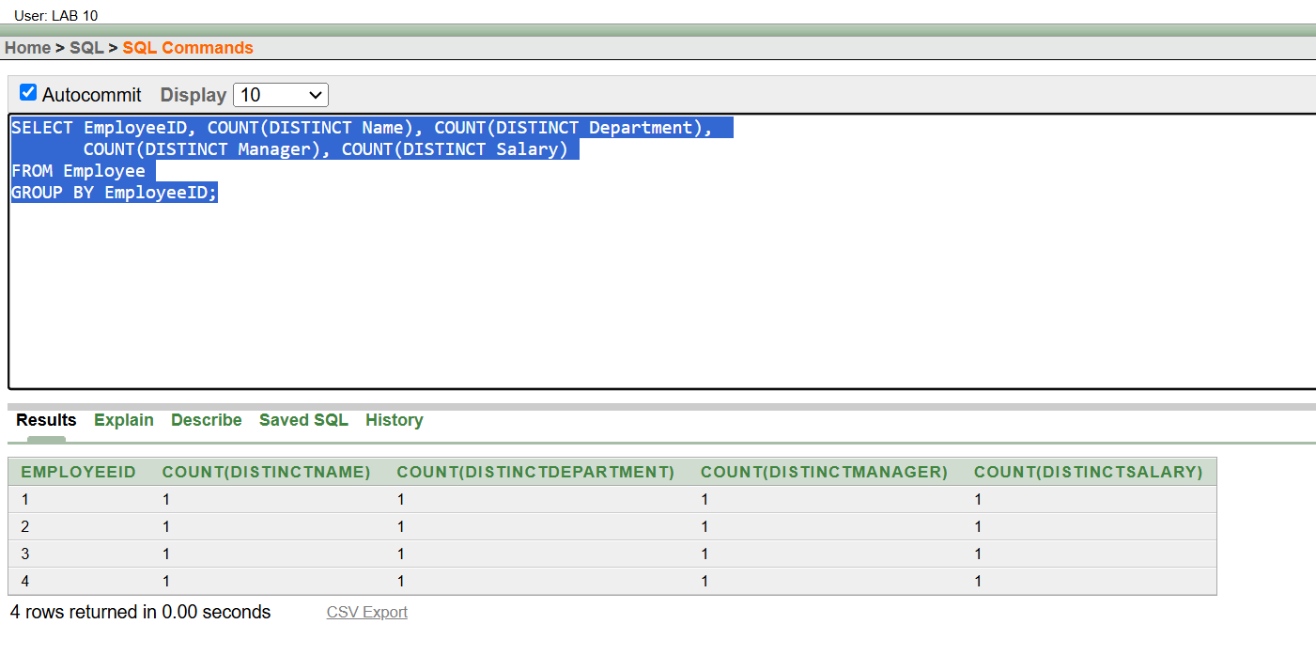

* + - Department → Manager

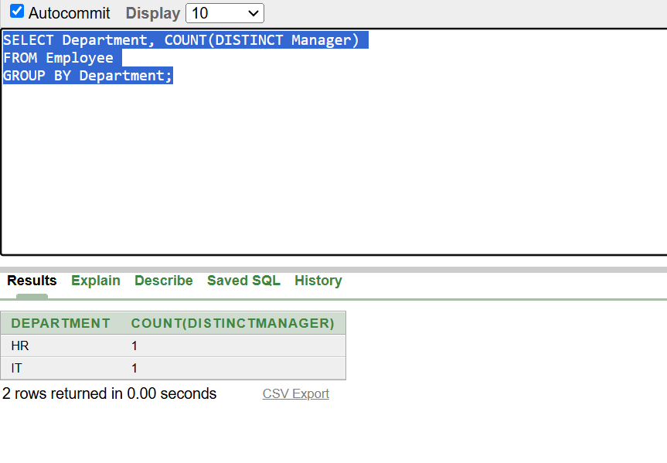

* + - Manager → Department

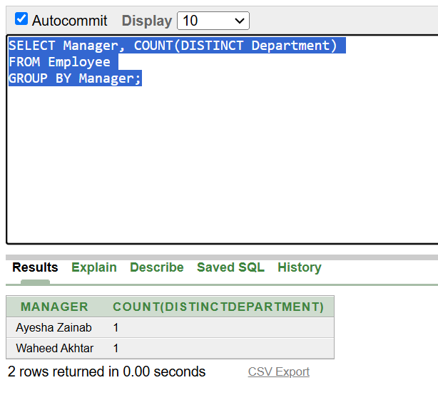

#### **Task 2: Analyze Complex Dependencies**

For the schema R(OrderID,CustomerID,ProductID,Quantity,Price)

* 1. Identify FDs (e.g., OrderID→CustomerID)
     + OrderID → CustomerID, ProductID, Quantity, Price
     + ProductID → Price
     + CustomerID → OrderID
  2. Populate the table and test if each FD holds.

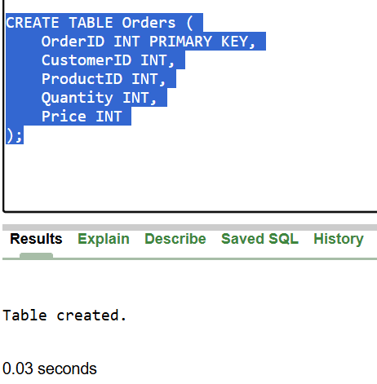

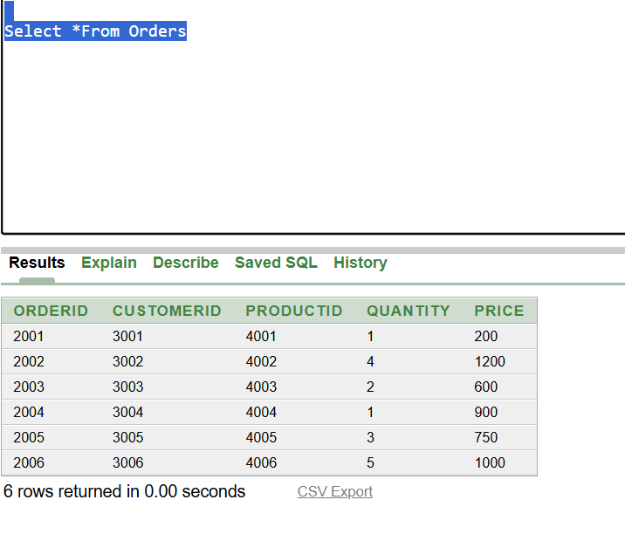

* + - OrderID → CustomerID, ProductID, Quantity, Price

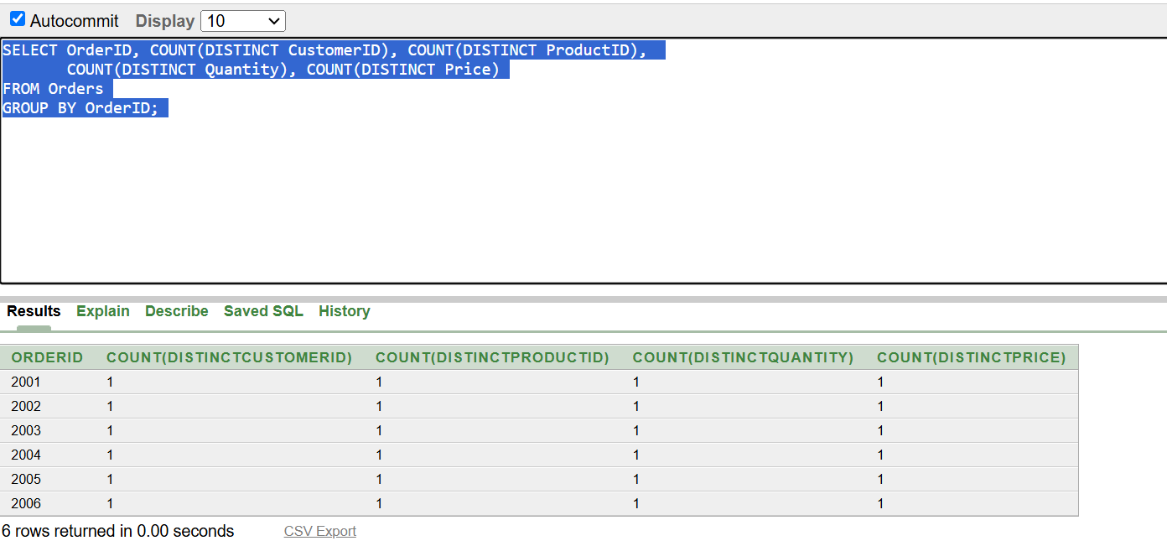

* + - ProductID → Price

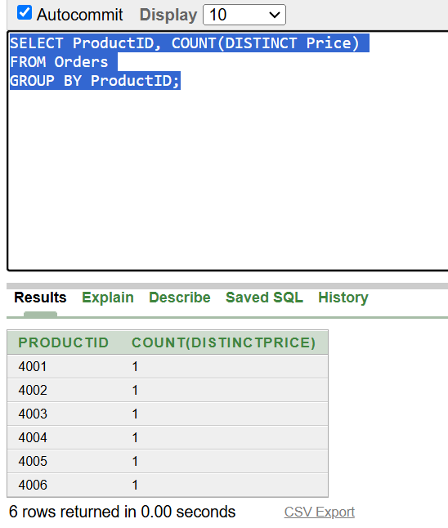

* + - CustomerID → OrderID

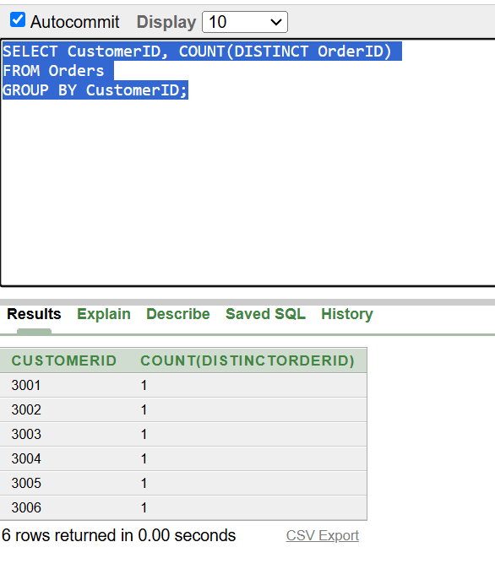

### **Lab Questions:**

1. **Define functional dependency. Provide an example.**

A Functional Dependency is a relationship between two attributes where one attribute uniquely determines another.

Example: In a schema R(StudentID, Name, Age) we have FD StudentID → Name, Age

1. How can you verify a functional dependency in a database?

We can verify the functional dependency by writing a query that will result in showing all determinants and the distinct count of all dependent attributes and grouping them by determinant. We will get all distinct counts equal to one and thus the functional dependency is verified. Following is an example of the verification of functional dependency of determinant (orderID) with dependents (CustomerID, ProductID, Quantity, Price ).



1. What are trivial and non-trivial FDs? Provide examples.

**Trivial FD:** A FD is trivial if the dependent attribute is a subset of the determinant.  
**Example:** {Name, Age} → Name.

**Non-Trivial FD:** A FD is non-trivial if the dependent attribute is not a subset of the determinant.  
**Example:** {StudentID} → Name

1. Identify and list FDs for the schema R(DoctorID,PatientID,AppointmentDate,Diagnosis)
   * + DoctorID, PatientID, AppointmentDate → Diagnosis
     + DoctorID → AppointmentDate
     + PatientID → Diagnosis